INFOSYS SPRINGBOARD VIRTUAL INTERNSHIP 6.0
( DATAVISUALIZATION )

Project Title:
Infosys_HotelRevai AI Driven Revenue Analysis for Hotels

Name of the Intern :
CHELIKANI HARSHAL

Milestone 3 :
DAX Metrics
Business Metrics

DAX METRICS

🔹 1. Average ADR
Average ADR = AVERAGE(hotel_booking_main[adr])
Used to understand pricing trends.

🔹 2. Total Bookings
Total Bookings = COUNTROWS(hotel_booking_main)
Core business metric.

🔹 3. Total Cancellations
Total Cancellations =
CALCULATE(
COUNTROWS(hotel_booking_main),
hotel_booking_main[is_canceled] = 1
)

🔹 4. Total Confirmed
Total Confirmed =
CALCULATE(
COUNTROWS(hotel_booking_main),
hotel_booking_main[is_canceled] = 0
)
🔹 5. Cancellation Rate %
Cancellation Rate % =
DIVIDE(
[Total Cancellations],
[Total Bookings],
0
)

🔹 6. Total Guests
Total Guests =
SUM(adults) + SUM(children) + SUM(babies)

🔹 7. Total Revenue
Total Revenue =
SUMX(
hotel_booking_main,
hotel_booking_main[adr] *
(stays_in_week_nights + stays_in_weekend_nights)
)

🔹 8. Total Nights
Total Nights =
SUM(stays_in_week_nights) +
SUM(stays_in_weekend_nights)

🔹 9. Revenue TY (Time Intelligence)
Revenue TY =
CALCULATE(
[Total Revenue],
DateTable[Year] = YEAR(TODAY())
)

DASHBOARD

BOOKING BEHAVIOUR ANALYSIS

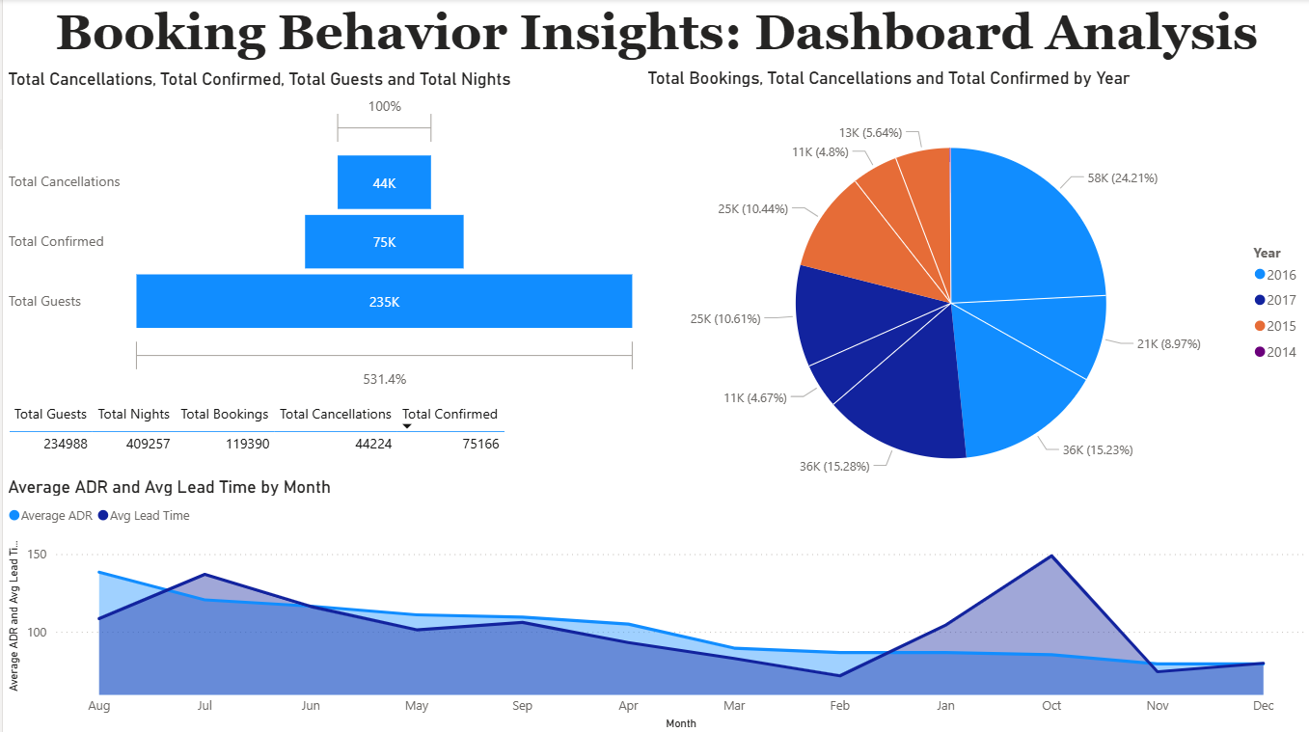

Key Visuals:
- Total bookings, confirmations, cancellations
- Year-wise distribution
- Average ADR vs Average Lead Time
(monthly trend)

Business Value:
- Identifies peak booking months
- Shows how lead time affects pricing
- Enables forecasting and demand planning

BUSINESS IMPACT

1️⃣ Revenue Optimization
- Identified top-performing market segments.
- Compared revenue performance between City and Resort hotels.
- Analyzed ADR trends across months and years.
- Evaluated revenue contribution by customer types.
2️⃣ Improved Occupancy & Demand Planning
- Analyzed booking distribution across years and months.
- Studied lead time patterns and stay duration.
- Evaluated guest volume trends (Adults, Children, Babies).
3️⃣ Risk Monitoring & Revenue Protection
- Measured cancellation rate and total cancellations.
- Identified seasonal and hotel-level cancellation risks.
4️⃣ Customer Segmentation & Targeting
- Segmented customers by market segment and customer type.
- Identified repeat guest percentage.
5️⃣ Data-Driven Decision Framework
- Created reusable DAX-based KPIs.
- Built interactive dashboards with dynamic filters.

